CURRICULUM VITAE

**AMAN** 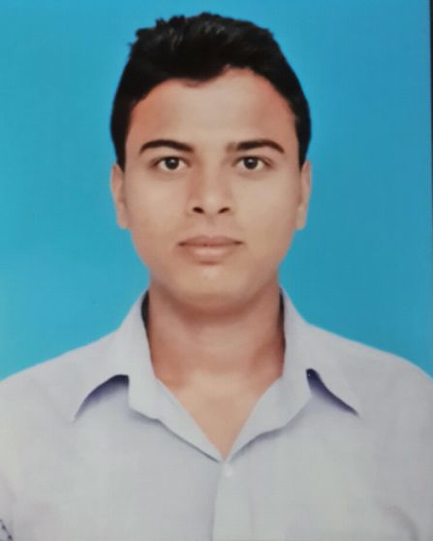

## *Professional Objective:*

To work in a Challenging Environment where I can Contribute my Knowledge and skills in a Effective Manner.

## *Education Details:*

* Completed B.SC from Ignou (Under Ministry Tourism Govt.of India) luckonow.
* 10th from **Haryana Board.**
* 12th from **Haryana Board.**
* 6th month basic computer course.

## *Area of working*

* Sales & marketing Department

## *Experience:*

* 3 year work experience in VISHWAKARMA AUTO PARTS PVT.LTD. at sales executive level and area sales officer. (NORTH INDIA)

## *Role & Responsibilities:-*

* Assure conformance to all Sales & Marketing standards and specifications set by the executive Marketing Manager.
* Maintain a sale scale and Balancing the company sale.
* Make out daily requisitions for the supplies needed with the approval of marketing manager.
* Ensure that employees in the department conform to house rules and policies of the company.
* Initiate the performance evaluation of subordinate staff.
* Personally supervise the maintain of proper company sale.

## *Other activities:*

* Basic Knowledge of Computer and internet.
* I like listening music in my free time .

## *Languages known:*

* Hindi, English, (can speak, read & write).

## *Achievements:*

* Won Prizes in **cricket** match in my School.
* Got **certificates in social awareness activity.(blood donation cam and ,road safety )**

## *Personal strengths:*

* Ability to work well under pressure, good team performer, self driven & highly motivated.
* Pleasing personality, positive attitude and good human being

## *Knowledge:*

* Personal hygine and customer service knowledge, processing & production sale of company material.

## *Personal Profile:*

Name :  **AMAN**

Father’s name : Mr.Rakesh kumar

Date of Birth : 02 feb.1996

Marital status : Single

Nationality : Indian

Address : H.No.B-882,Near Balaji Mandir Road

ADARSH NAGAR Ballabgarh,Faridabad (HR)121004

Mob. : **08586997976**

Email : [amanihmlko1996@gmail.com](mailto:amanihmlko1996@gmail.com)

**DECLARATION:**

I hereby declare that all the details provide by me in this application is factual and correct to the best of my knowledge.

**Date ( AMAN )**